A Decade of Spotify Hits: How the Sound of Popular Music Changed from 2010-2019

Lucy Dowdle
MSDS 670: Data Visualization
Professor John Koenig
28 June 2026

Introduction
Spotify is a music streaming service that has reshaped how popular music is made and measured. Services like Spotify can quantify music with dimensions such as energy, danceability, and loudness to understand what those songs sounded like. This project examines the most popular songs of the 2010s to ask how their audio characteristics changed across the decade and how those characteristics relate to one another.
Research Question
How did the audio characteristics of Spotify’s most popular songs change over the 2010–2019 decade, and which musical attributes are associated with one another? Along with this, three sub questions were used to help focus the visualizations. Did the energy and danceability of top songs trend upward or downward across the decade? Which genres dominated the decade’s most popular songs? Is a song’s loudness related to its perceived energy?
Data
The dataset, “Top Spotify Songs 2010–2019,” contains 603 of the decade’s most popular tracks, with attributes including release year, genre, beats per minute, energy, danceability, loudness, valence, and popularity. The scores are derived from Spotify’s own analysis, with most features expressed on a 0–100 scale and loudness measured in decibels (dB).
Methodology
All work was performed in Python using the panda’s library for data handling and matplotlib, in its stateless interface, for visualization. First, the dataset’s long descriptive column headers were renamed to concise labels. Second, rows missing a year or genre were removed, and the relevant feature columns were converted to numeric types. Third, during exploratory analysis one record—Adele’s “Million Years Ago,” listed at −60 dB with an energy score of zero—was identified as a data-entry error, since a released track cannot be effectively silent. Removing these outliers strengthened the observed correlation from 0.54 to 0.64, producing a more accurate estimate of the underlying relationship. Three visualizations were then produced: a line plot, a sorted horizontal bar plot, and a scatter plot, each with a descriptive title, labeled axes with units, rounded data labels, and no gridlines.
Results
Trends in Energy and Danceability
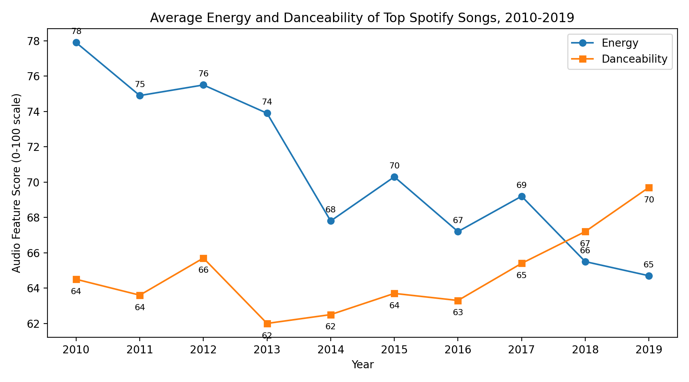
Figure 1. Average energy and danceability of top Spotify songs by year, 2010–2019.

Figure 1 shows the average energy declined steadily across the decade, falling from 78 in 2010 to 65 in 2019. Danceability moved in the opposite direction, rising from 64 to 70 and climbing fastest after 2016. The two lines cross around 2018, the point at which danceability overtakes energy. This crossing shows the decade’s hits traded intensity for a more rhythm-forward sound.
Genre Dominance
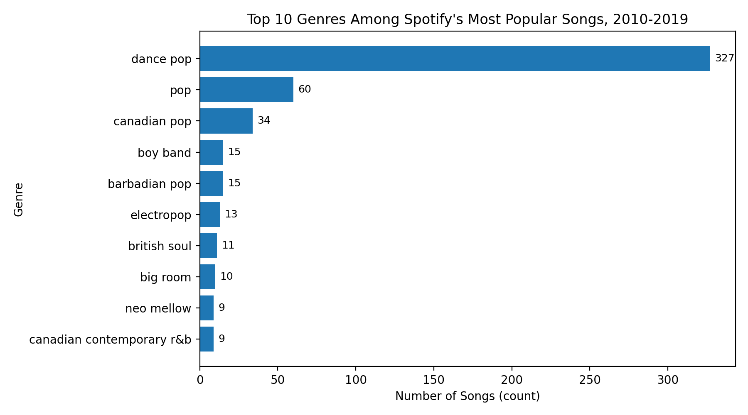
Figure 2. The ten most frequent genres among the decade’s most popular songs.
Figure 2 shows the genres from the decade with Dance pop dominating with 327 of the 603 songs, which is more than half of every top track in the decade. Plain pop (60) and Canadian pop (34) follow far behind, and pop-derived genres fill nearly the entire top ten. The popular music of the 2010s, at least as captured by these charts, was overwhelmingly pop based.
Loudness and Energy
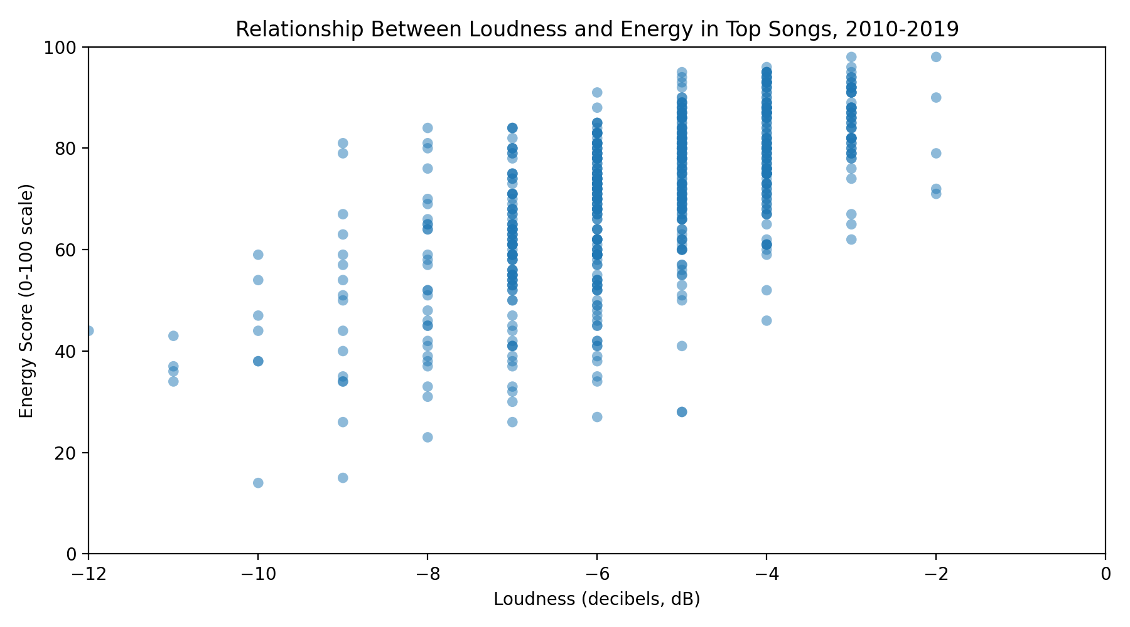
Figure 3. Relationship between loudness (dB) and energy for top songs.
Figure 3 looks at whether louder songs are also more energetic and studies that correlation. The data-entry errors were removed, and the two features show a moderate positive correlation of 0.64. The upward trend is consistent as louder songs tend to be more energetic, yet loudness alone does not guarantee high energy. The vertical banding in the plot reflects the fact that loudness is recorded in whole-decibel increments, causing songs to stack on discrete values.
Conclusions
From this analysis there are a few conclusions arising: First, the sound of popular music shifted measurably over the 2010s, trading energy for danceability, with 2018 marking a turning point. Second, the decade was dominated by dance pop as it accounted for more than half of all top tracks. Third, loudness and energy are positively related, with a correlation of 0.64. Together these findings show that quantitative audio features can tell a story about how popular music evolved.

